Hospital Management System

Submitted By

Student Name | Student ID
Student-1 Name | Student-1 ID
Student-2 Name | Student-2 ID
Student-3 Name | Student-3 ID
Student-4 Name | Student-4 ID
Student-5 Name | Student-5 ID

MINI LAB PROJECT REPORT
This Report Presented in Partial Fulfillment of the course CSE 324: Operating System Lab in the Computer Science and Engineering Department



DAFFODIL INTERNATIONAL UNIVERSITY
Dhaka, Bangladesh
November 2, 2024

DECLARATION
We hereby declare that this lab project has been done by us under the supervision of Md. Taufik Hasan, Lecturer, Department of Computer Science and Engineering, Daffodil International University. We also declare that neither this project nor any part of this project has been submitted elsewhere as lab projects.

Submitted To:

Course Teacher’s Name: Md. Taufik Hasan
Designation: Lecturer
Department of Computer Science and Engineering Daffodil International University

Submitted by

Student Name Student ID:
Dept. of CSE, DIU
Student Name Student ID:  Dept. of CSE, DIU | Student Name Student ID:  Dept. of CSE, DIU
Student Name Student ID:  Dept. of CSE, DIU | Student Name Student ID:  Dept. of CSE, DIU

COURSE & PROGRAM OUTCOME

The following course have course outcomes as following:

Table 1: Course Outcome (CO) Statements
CO’s | Course Outcome Statements
CO1 | Identify and explain fundamental operating system concepts such as processes, file systems, user input/output, and command-line interaction required for console-based applications.
CO2 | Apply Bash shell scripting techniques in the Ubuntu terminal to design and implement a menu-driven hospital management system.
CO3 | Analyze system workflow and data handling mechanisms in a terminal-based environment to represent and manage real-world problem scenarios effectively.
CO4 | Develop and evaluate a complete console-based software solution using shell scripting by considering functionality, efficiency, and practical usability.

Table 2: Mapping of CO, PO, Blooms, KP and CEP
CO | PO | Blooms | KP | CEP
CO1 | PO1 | C1, C2 | KP3 | EP1, EP3
CO2 | PO2 | C2 | KP3 | EP1, EP3
CO3 | PO3 | C4, A1 | KP3 | EP1, EP2
CO4 | PO3 | C3, C6, A3,  P3 | KP4 | EP1, EP3

The mapping justification of this table is provided in section 4.3.1, 4.3.2 and 4.3.3.

Table of Contents

Declaration i

Course & Program Outcome ii
- Introduction 1
  - Introduction 1
  - Motivation 1
  - Objectives 1
  - Feasibility Study 1
  - Gap Analysis 1
  - Project Outcome 1
- Proposed Methodology/Architecture 2
  - Requirement Analysis & Design Specification 2
    - Overview 2
    - Proposed Methodology/ System Design 2
    - UI Design 2
  - Overall Project Plan 2
- Implementation and Results 3
  - Implementation 3
  - Performance Analysis 3
  - Results and Discussion 3
- Engineering Standards and Mapping 4
  - Impact on Society, Environment and Sustainability 4
    - Impact on Life 4
    - Impact on Society & Environment 4
    - Ethical Aspects 4
    - Sustainability Plan 4
  - Project Management and Team Work 4
  - Complex Engineering Problem 4
    - Mapping of Program Outcome 4
    - Complex Problem Solving 4
    - Engineering Activities 5

Table of Contents Table of Contents

- Conclusion 6
  - Summary 6
  - Limitation 6
  - Future Work 6
References 6

Chapter 1

Introduction

This chapter outlines the background of the project, identifies the existing problem, explains the motivation behind the work, defines the project objectives, evaluates feasibility, analyzes existing gaps, and presents the expected outcomes of the proposed system.

Introduction
Efficient management of hospital-related information is essential for ensuring smooth healthcare operations. However, in many academic and institutional environments, including Daffodil International University, there is currently no centralized system to manage basic healthcare administrative activities in a structured and automated manner.
The absence of such a system often results in manual record keeping, lack of organization, and inefficiencies in handling patient data, doctor information, medical history, inventory, and billing processes. To address this issue, this project proposes the development of a console-based Hospital Management System using Bash shell scripting in the Ubuntu operating system, aiming to provide a simple, reliable, and accessible solution through a terminal-based interface.

Motivation
The primary motivation behind this project is to apply operating system concepts and shell scripting techniques to solve a real-world problem in a practical and meaningful way. Developing a terminal-based hospital management system enables the implementation of file handling, process execution, and user interaction within the Linux command-line environment.
Additionally, the lack of an existing hospital management application or web-based system within the campus environment motivated the initiative to design such a solution independently. This project enhances technical skills, encourages problem-solving, and provides valuable experience in developing lightweight software systems without relying on graphical interfaces or database technologies.

Objectives
The key objectives of this project are as follows:
- To design and implement a menu-driven hospital management system using Bash shell scripting
- To manage patient, doctor, appointment, medical history, inventory, and billing information through the Ubuntu terminal
- To store and retrieve data efficiently using file-based storage mechanisms
- To apply core operating system principles in a practical software solution
- To develop a user-friendly and maintainable console-based application

Feasibility Study
Numerous hospital management systems have been developed as web-based and mobile applications, offering advanced features such as graphical dashboards, database integration, and cloud-based services. While these systems are effective for large-scale institutions, they require significant computational resources, internet connectivity, and complex deployment environments.
In contrast, this project adopts a terminal-based approach using Bash shell scripting, which is highly feasible in an academic setting. The system operates efficiently on the Ubuntu operating system without the need for external frameworks or databases. Similar academic and research-based projects demonstrate that console-based systems are suitable for managing essential data and are effective for educational and small-scale institutional use.

Gap Analysis
Existing hospital management solutions primarily focus on graphical interfaces and database-driven architectures, which are not always accessible or necessary for all environments. Moreover, there is a noticeable lack of terminal-based hospital management systems that exclusively utilize shell scripting to demonstrate operating system concepts.
Within Daffodil International University, no such application or web-based system currently exists to manage healthcare administrative tasks in a centralized manner. This project fills the gap by providing a lightweight, console-based solution that demonstrates how essential hospital management functionalities can be implemented using only the Ubuntu terminal and Bash scripting.

Project Outcome
The expected outcomes of this project include:
- A fully functional Ubuntu terminal-based Hospital Management System
- Improved practical understanding of Linux operating systems and shell scripting
- Efficient management of hospital-related data through structured text files
- Enhanced skills in system-level programming and command-line application development
- A scalable academic project that can be extended with additional features in the future

Chapter 2

Proposed Methodology/Architecture

This chapter explains the proposed methodology, system architecture, requirement analysis, user interface design, and project planning approach used to develop the Ubuntu terminal-based Hospital Management System.

Requirement Analysis & Design Specification

The requirement analysis phase identifies the functional and non-functional requirements of the system based on the actual modules implemented. The design specification defines how these requirements are fulfilled using Bash shell scripting in a console environment.

Overview
The proposed system is a menu-driven Hospital Management System developed using Bash shell scripting and executed in the Ubuntu terminal. The system is designed to manage hospital administrative tasks through text-based interaction and file-based data storage.
The system consists of the following core modules:
- Patient Management
- Doctor Management
- Appointment Management
- Medical History
- Pharmaceutical Inventory
- Billing System
Each module operates independently but is integrated through a centralized main menu for seamless navigation.

Proposed Methodology/ System Design

The system follows a procedural and modular scripting methodology, where each hospital management function is implemented as a separate function within the shell script.

System Workflow
- The user launches the shell script from the Ubuntu terminal
- The Main Menu is displayed with available modules
- The user selects a specific module
- The selected module performs operations such as Add, View, Search, or Update
- Data is stored and retrieved from text files
- Control returns to the main menu

Hospital Management System:
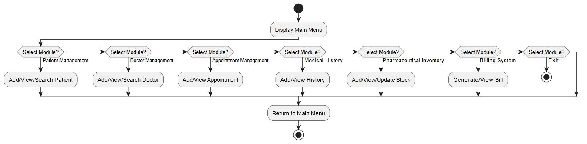
Fig: Hospital Management System Activity Diagram

Module-wise Design:
Patient Management Module:
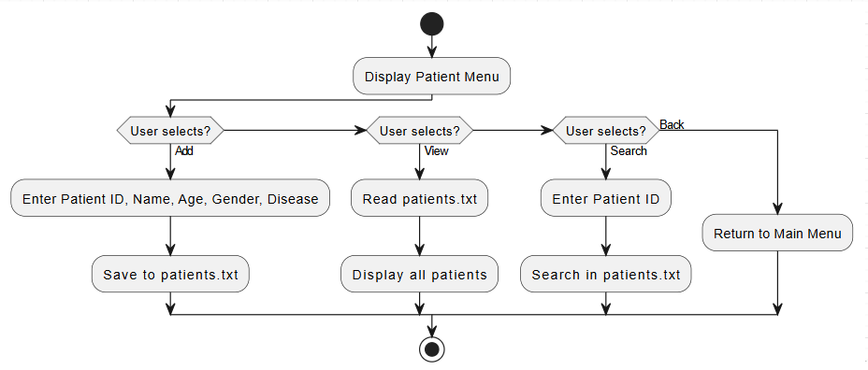
Fig: Patient Management Module Activity Diagram
Doctor Management Module:
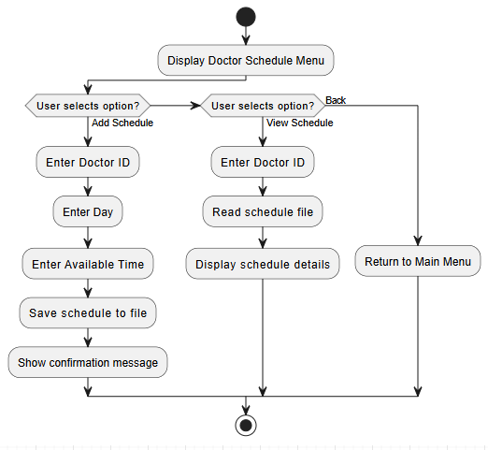
Fig: Doctor Management Module Activity Diagram
Appointment Management Module:
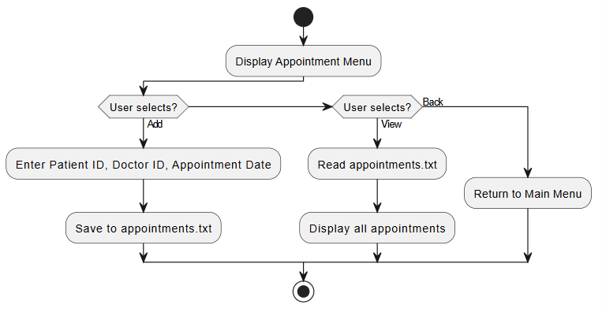
Fig: Appointment Management Module Activity Diagram
Medical History Module:
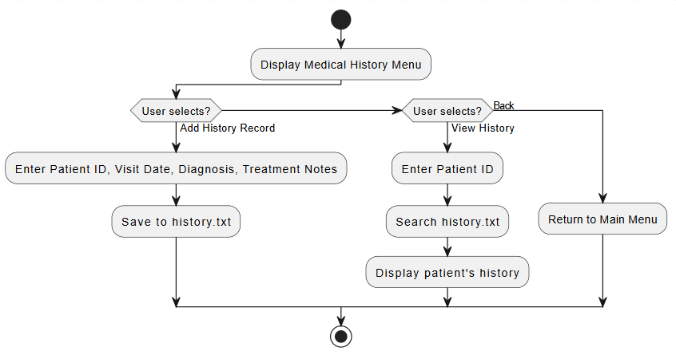
Fig: Medical History Module Activity Diagram

Inventory Module:

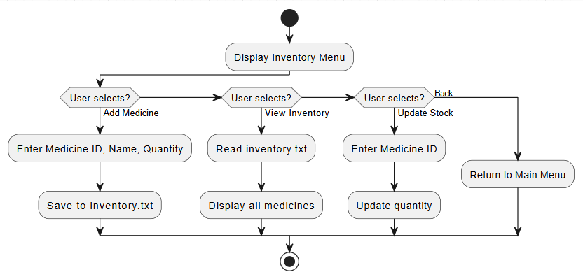

Fig: Inventory Module Activity Diagram

Billing System Module:
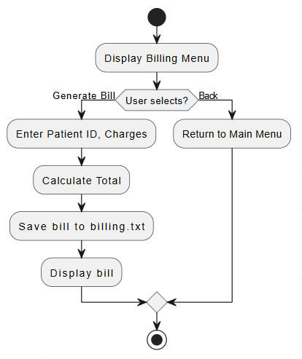

Fig: Billing System Module Activity Diagram

UI Design:

Overall Project Plan

The Hospital Management System was developed using a structured and phased approach to ensure systematic progress and successful implementation. Each phase focused on specific tasks, starting from requirement analysis and system design to implementation, testing, and documentation, using Bash shell scripting in the Ubuntu terminal environment.

2.2.1 Overall Project Timeline and Plan

Phase | Activity | Description
Requirement Analysis | Problem identification and module selection | Identified system requirements and finalized project modules including Patient Management, Doctor Schedule, Appointment Management, Medical History, Inventory, and Billing System.
System Design | Menu structure and data design | Designed a menu-driven console interface and defined file formats for data storage.
Implementation | Shell script development | Implemented all modules using Bash shell scripting in the Ubuntu terminal.
Testing & Validation | Functional testing | Tested system functionality, handled user input errors, and validated data processing.
Documentation | Report preparation | Prepared UML diagrams, methodology, and final project documentation.

Fig: Overall Project Timeline and Plan

Chapter 3

Implementation and Results

This chapter describes the implementation details of the proposed Hospital Management System, analyzes its performance in a terminal-based environment, and discusses the results obtained from system execution and testing.

Implementation
The Hospital Management System was implemented using Bash shell scripting and executed in the Ubuntu terminal. The system follows a menu-driven architecture, where each functional module is implemented as a separate function within the shell script. The main menu controls user navigation and directs operations to specific modules.
Data persistence is achieved using text files, where each module stores and retrieves information in a structured format. For example, patient records, doctor schedules, appointments, medical history, inventory, and billing information are stored in separate files. Standard Linux commands such as read, echo, grep, and file redirection operators are used to handle user input and file operations.
The implementation emphasizes simplicity, modularity, and clarity, ensuring that the system remains easy to maintain and extend while effectively demonstrating operating system concepts.

Performance Analysis
The performance of the system was evaluated based on response time, resource usage, and reliability in a console-based environment. Since the application operates entirely in the terminal and uses file-based storage, it requires minimal system resources.
System response time for operations such as adding, viewing, and searching records was found to be fast due to the lightweight nature of Bash scripting and text file handling. The absence of graphical components and database overhead further contributes to efficient execution.
Overall, the system performs efficiently on standard Ubuntu installations and is suitable for small-scale administrative tasks in an academic or controlled environment.

Results and Discussion
The implementation of the Hospital Management System successfully met all the defined objectives. The system allows users to manage patient information, doctor schedules, appointments, medical history, pharmaceutical inventory, and billing operations through a structured terminal interface.
Testing results indicate that the system performs reliably and handles user interactions as expected. While the system lacks advanced features such as graphical interfaces and database integration, it effectively fulfills its purpose as a console-based management system and serves as a practical demonstration of shell scripting and operating system concepts.
The results confirm that a functional and efficient hospital management system can be developed using basic Linux tools, making this project suitable for academic learning and further enhancement.

Table 3.1: Test Case Summary for Hospital Management System:

Test Case ID | Module | Test Description | Input | Expected Output | Actual Output | Status
TC-01 | Patient Management | Add new patient record | Patient ID, Name, Age, Gender, Disease | Patient data saved successfully | Patient record saved | Pass
TC-02 | Patient Management | View patient list | View option selected | All patient records displayed | Patient list displayed | Pass
TC-03 | Patient Management | Search patient by ID | Valid Patient ID | Patient information displayed | Correct patient found | Pass
TC-04 | Doctor Schedule | Add doctor schedule | Doctor ID, Day, Time | Schedule saved successfully | Schedule added | Pass
TC-05 | Doctor Schedule | View doctor schedule | Doctor ID | Schedule displayed | Schedule displayed | Pass
TC-06 | Appointment Management | Add appointment | Patient ID, Doctor ID, Date | Appointment stored successfully | Appointment added | Pass
TC-07 | Appointment Management | View appointments | View option selected | Appointment list displayed | Appointment list displayed | Pass
TC-08 | Medical History | Add medical history record | Patient ID, Date, Diagnosis, Notes | History record saved | History added | Pass
TC-09 | Medical History | View patient history | Patient ID | Medical history displayed | History displayed | Pass
TC-10 | Inventory Management | Add medicine | Medicine ID, Name, Quantity | Medicine saved to inventory | Medicine added | Pass
TC-11 | Inventory Management | Update medicine stock | Medicine ID, Updated quantity | Inventory updated | Stock updated | Pass
TC-12 | Billing System | Generate patient bill | Patient ID, Charges | Bill generated and stored | Bill generated | Pass

Chapter 4

Engineering Standards and Mapping

This chapter presents a comprehensive discussion on the engineering standards followed in the development of the Hospital Management System. It analyzes the project’s impact on society, environment, and sustainability, highlights project management and teamwork practices, and maps the system to program outcomes and complex engineering problem-solving frameworks as defined by professional engineering bodies.

Impact on Society, Environment and Sustainability

Impact on Life
The Hospital Management System plays a significant role in improving day-to-day healthcare administrative activities. By automating core operations such as patient registration, doctor scheduling, appointment handling, medical history recording, pharmaceutical inventory, and billing, the system reduces manual workload and administrative delays. This directly enhances the efficiency of hospital staff and improves the overall patient experience.
In a campus-based healthcare environment like Daffodil International University, such a system can facilitate faster service delivery, organized record management, and improved decision-making. The availability of structured digital records minimizes the chances of data loss and enables consistent monitoring of patient-related information.

Impact on Society & Environment
From a societal perspective, the system encourages the adoption of digital solutions in healthcare administration, promoting efficiency, transparency, and accountability. The structured handling of patient and operational data supports better healthcare planning and management.
Environmentally, the system significantly reduces the need for paper-based documentation. By digitizing patient records, appointment schedules, and inventory logs, the project contributes to environmental sustainability through reduced paper consumption, printing costs, and physical storage requirements. Such digital transformation aligns with global initiatives toward environmentally responsible computing practices.

Ethical Aspects
Ethical considerations are crucial in healthcare-related software systems. This project addresses ethical responsibilities by emphasizing accurate data entry, data consistency, and responsible system usage. Although the system uses simple text files for data storage, it demonstrates fundamental ethical principles such as data confidentiality, integrity, and accountability.
The project also highlights the importance of access control and secure data handling, even in a learning environment. By following ethical software development practices, the system aligns with professional engineering standards and prepares students to handle real-world healthcare data responsibly.

Sustainability Plan
The Hospital Management System is designed with sustainability in mind. The use of open-source technologies such as Ubuntu Linux and Bash shell scripting ensures long-term viability without licensing costs. The modular structure of the system allows easy maintenance, updates, and feature enhancements.
Future sustainability plans include the integration of authentication mechanisms, database-backed storage systems, and graphical or web-based interfaces. These enhancements would improve scalability, security, and usability while preserving the core system architecture.

Project Management and Team Work
The successful completion of the project was achieved through effective project management and collaborative teamwork. The development process followed a structured approach, beginning with requirement analysis and progressing through design, implementation, testing, and documentation phases.
Each team member was assigned specific responsibilities to ensure balanced workload distribution and accountability. Regular meetings and coordination helped resolve issues efficiently and maintained consistency across modules.
Cost Analysis and Revenue Model:
Item | Primary Budget (BDT) | Alternate Budget (BDT) | Rationale
Hardware | 0 | 30,000 | Existing personal computers used; alternate includes institutional systems
Software | 0 | 5,000
  Ubuntu OS and Bash scripting are open-source
Development Tools | 0 | 3,000 | Optional development utilities
Maintenance | 0 | 10,000
  System updates and long-term support
Total | 0 | 48,000 | Minimal cost through open-source adoption
Revenue Model:
Although developed as an academic project, the system has potential for real-world adaptation. Revenue may be generated through customization for small clinics, campus healthcare centers, or training institutions, along with maintenance and support services.

Complex Engineering Problem

The project represents a complex engineering problem due to the integration of multiple interdependent modules within a command-line environment. Managing data consistency, user interaction, and system reliability using limited system resources requires structured engineering analysis and careful implementation.

Mapping of Program Outcome

Table 4.1: Justification of Program Outcomes
PO’s | Justification
PO1
  Applied knowledge of operating systems and shell scripting to design a functional management system
PO2 | Analyzed real-world healthcare problems and formulated appropriate technical solutions
PO3 | Designed, implemented, tested, and evaluated the system following engineering best practices

Complex Problem Solving
Developing the system involved addressing challenges such as managing multiple file-based datasets, handling user input validation, and maintaining module interdependency. These challenges required in-depth analysis and systematic problem-solving strategies.
Table 4.2: Mapping with complex problem solving.
EP1  Dept of Knowledge | EP2  Range of Conflicting Requirements | EP3  Depth of Analysis | EP4  Familiarity of Issues | EP5  Extent of Applicable Codes | EP6  Extent  Of Stakeholder Involvement | EP7  Inter- dependence
Operating Systems, Shell Scripting | Usability vs system simplicity | File handling and validation | Common healthcare operations | Linux OS standards | Students, instructors, users | Interlinked modules

Engineering Activities
The project demonstrates a wide range of engineering activities, including system analysis, architectural design, coding, testing, debugging, and documentation. These activities reflect professional engineering practice and teamwork.

Table 4.3: Mapping with complex engineering activities.
EA1  Range of resources | EA2  Level of Interaction | EA3  Innovation | EA4  Consequences for society and  environment | EA5  Familiarity
Open-source platforms | Team collaboration | Console-based automation | Reduced paperwork and improved efficiency | Familiar healthcare processes

Chapter 5

Conclusion

This chapter provides a comprehensive conclusion of the Hospital Management System project by summarizing the overall work, identifying existing limitations, and proposing future enhancements that could improve the system’s functionality, usability, and scalability.

Summary
The Hospital Management System was successfully designed and implemented as a console-based application using Bash shell scripting in the Ubuntu Linux environment. The project aimed to address the absence of a simple and organized healthcare management system within the campus environment by providing an efficient solution for managing essential hospital operations.
The system incorporates multiple functional modules, including Patient Management, Doctor Management, Appointment Scheduling, Medical History Tracking, Pharmaceutical Inventory Management, and Billing System. Each module is implemented in a structured and modular manner, allowing smooth navigation through a menu-driven interface. Persistent data storage is achieved using text files, which ensures simplicity and effective demonstration of core operating system concepts such as file handling, process execution, and command-line interaction.
Throughout the development process, careful attention was given to system design, usability, and reliability. The project successfully demonstrates how basic Linux tools and shell scripting can be utilized to develop a practical, real-world application. The achieved outcomes confirm that a functional hospital management system can be implemented effectively within a constrained, terminal-based environment.

Limitation
Despite meeting its objectives, the system has certain limitations that restrict its applicability in real-world healthcare environments. The most notable limitation is the absence of a graphical user interface, which may reduce ease of use for non-technical users. Additionally, the use of plain text files for data storage limits system scalability and may lead to performance issues when handling large datasets.
The system currently lacks advanced security mechanisms such as user authentication, role-based access control, and data encryption. As a result, patient data confidentiality and system security are not fully ensured. Error handling and input validation are implemented at a basic level and could be further strengthened to improve robustness and fault tolerance.
These limitations are acceptable within the academic scope of an Operating Systems course project; however, they highlight important areas that must be addressed for practical deployment.

Future Work

There is significant scope for enhancing the Hospital Management System in future developments. One major improvement would be the introduction of a graphical user interface (GUI) or web-based interface, which would greatly enhance user experience and accessibility. Integrating a database management system such as MySQL or PostgreSQL would improve data security, integrity, and scalability.
Future versions of the system may also include user authentication, role-based access control, and encryption techniques to ensure secure handling of sensitive medical information. Additional features such as automated report generation, data backup and recovery, notification systems, and network-based access could further enhance system functionality.
By implementing these enhancements, the project can evolve from an academic prototype into a robust, scalable, and industry-ready hospital management solution suitable for real-world applications.

References

[1] A. Silberschatz, P. B. Galvin, and G. Gagne, Operating System Concepts, 10th ed. Hoboken, NJ, USA: John Wiley & Sons, 2018.

[2] W. Shotts, The Linux Command Line: A Complete Introduction, 2nd ed. San Francisco, CA, USA: No Starch Press, 2019.

[3] R. Love, Linux System Programming: Talking Directly to the Kernel and C Library, 2nd ed. Sebastopol, CA, USA: O’Reilly Media, 2013.

[4] I. Sommerville, Software Engineering, 10th ed. Boston, MA, USA: Pearson Education, 2016.

[5] R. S. Pressman and B. R. Maxim, Software Engineering: A Practitioner’s Approach, 8th ed. New York, NY, USA: McGraw-Hill Education, 2015.

[6] M. Fowler, UML Distilled: A Brief Guide to the Standard Object Modeling Language, 3rd ed. Boston, MA, USA: Addison-Wesley, 2004.

[7] Free Software Foundation, “GNU Bash Reference Manual.” [Online]. Available: https://www.gnu.org/software/bash/manual/. Accessed: Dec. 14, 2025.

[8] Ubuntu Documentation Team, “Ubuntu Official Documentation.” [Online]. Available: https://help.ubuntu.com/. Accessed: Dec. 14, 2025.

[9] J. W. Satzinger, R. B. Jackson, and S. D. Burd, Systems Analysis and Design in a Changing World, 7th ed. Boston, MA, USA: Cengage Learning, 2016.

[10] IEEE Computer Society, “IEEE Code of Ethics.” [Online]. Available: https://www.ieee.org/about/corporate/governance/p7-8.html. Accessed: Dec. 14, 2025.

